MAE 770, Combustion of Reacting Flows

Project 2: Reacting-Gas Nozzle Flow, Re-Entry Conditions

Sailor Koeplinger

**Objective**: Write a program to solve the steady state quasi 1D reacting-gas nozzle problem in re-entry-like conditions for 5 species air and thermal nonequilibrium. The problem setup is described in detail in the project prompt. One difference is that this work uses a modification of the McBride curve fits for computing non-equilibrium thermodynamics instead of other thermodynamic state descriptions.

**Spatial Discretization**: Finite Volume with upwinding (**LDFSS** and **Van Leer)**.

**Integration/Solution Process**: Explicit handling of fluxes, implicit handling of thermochemical nonequilibrium source terms. Solution is initialized and advanced in pseudo-time until the convergence criterion is met. To solve the implicit system on each element, LU factorization with partial pivoting was used. The primitive variables solved for are $V=[ρ_{N2}, ρ_{O2}, ρ_{NO}, ρ_{N},ρ_{O},u,T,T_{v}]$. For stepping in pseudo-time: $dt=dx\frac{CFL}{a+|u|}$. Typical CFL values used are in the range of 0.4-0.1.

**Convergence:** The convergence criteria is set to be when the sum of normalized residuals is below 10-6. The species density residuals are normalized by the sum of the initial species density residuals. The energy residuals were each normalized by their initial value.

$\frac{∑|\left|R_{s}\right||}{∑|\left|R_{s0}\right||}+\frac{|\left|R_{Et}\right||}{|\left|R_{Et0}\right||}+\frac{|\left|R_{Ev}\right||}{|\left|R_{Ev0}\right||}<{10}^{-6}$ where $||*||$ indicates an L2 norm.

**Initialization**: The flow was initialized using two reference conditions. The first is the freestream/inlet condition, which was used to initialize the flow from x=0 to x=0.8. The second is an approximate post-shock conditions are calculated using normal shock relations, which is used to initialize the rest of the flow.

**Boundary Condition**: The ghost cell method is used to enforce boundary conditions. The inflow (left) boundary cell is set to freestream conditions. The outflow (right) cell is set to provide backpressure by manipulating mixture density in the ghost cell.

**Chemistry:** 5 species air with 5 reactions for the dissociation of O­2, N2, and NO, and the production of NO. McBride-type curve fits are used to calculate enthalpies and specific heats. The standard Arrhenius form is used for the forward reaction rates, and the equilibrium reaction rate is determined using the given expression. Chemical source terms are set to 0 for temperatures below 1000K, to remain within the limits of the curve fit. Rates are evaluated using $T^{*}= \sqrt{T_{tr}T_{ve}}$. These source terms are included in the residual vector, and the Jacobians for which also represented in the implicit operator. Checks are in place for conservation of mass and moles of elements.

**Thermal Nonequilibrium**: Thermal nonequilibrium was done in the manner described in the Vulcan CFD Theory Manual. A two-temperature model was used which consists of a temperature for translation and vibrational modes, Ttr­, and one for vibrational and electronic modes, Tve. It is assumed that the trans-rot energy modes are fully excited, implying that the respective specific heats are constant. With that assumption, the McBride curve fits can be split into a partition which contributes to the trans-rot energy and another which contributes to the vib-electric energy. Only the trans-rot temperature is used for pressure calculations and any other applications of the perfect gas assumption for gas mixtures. The Landau-Teller vibrational/translational energy relaxation process is used with the relaxation time model of Millikan and White. These source terms are included in the residual vector, and the Jacobians for which also represented in the implicit operator.

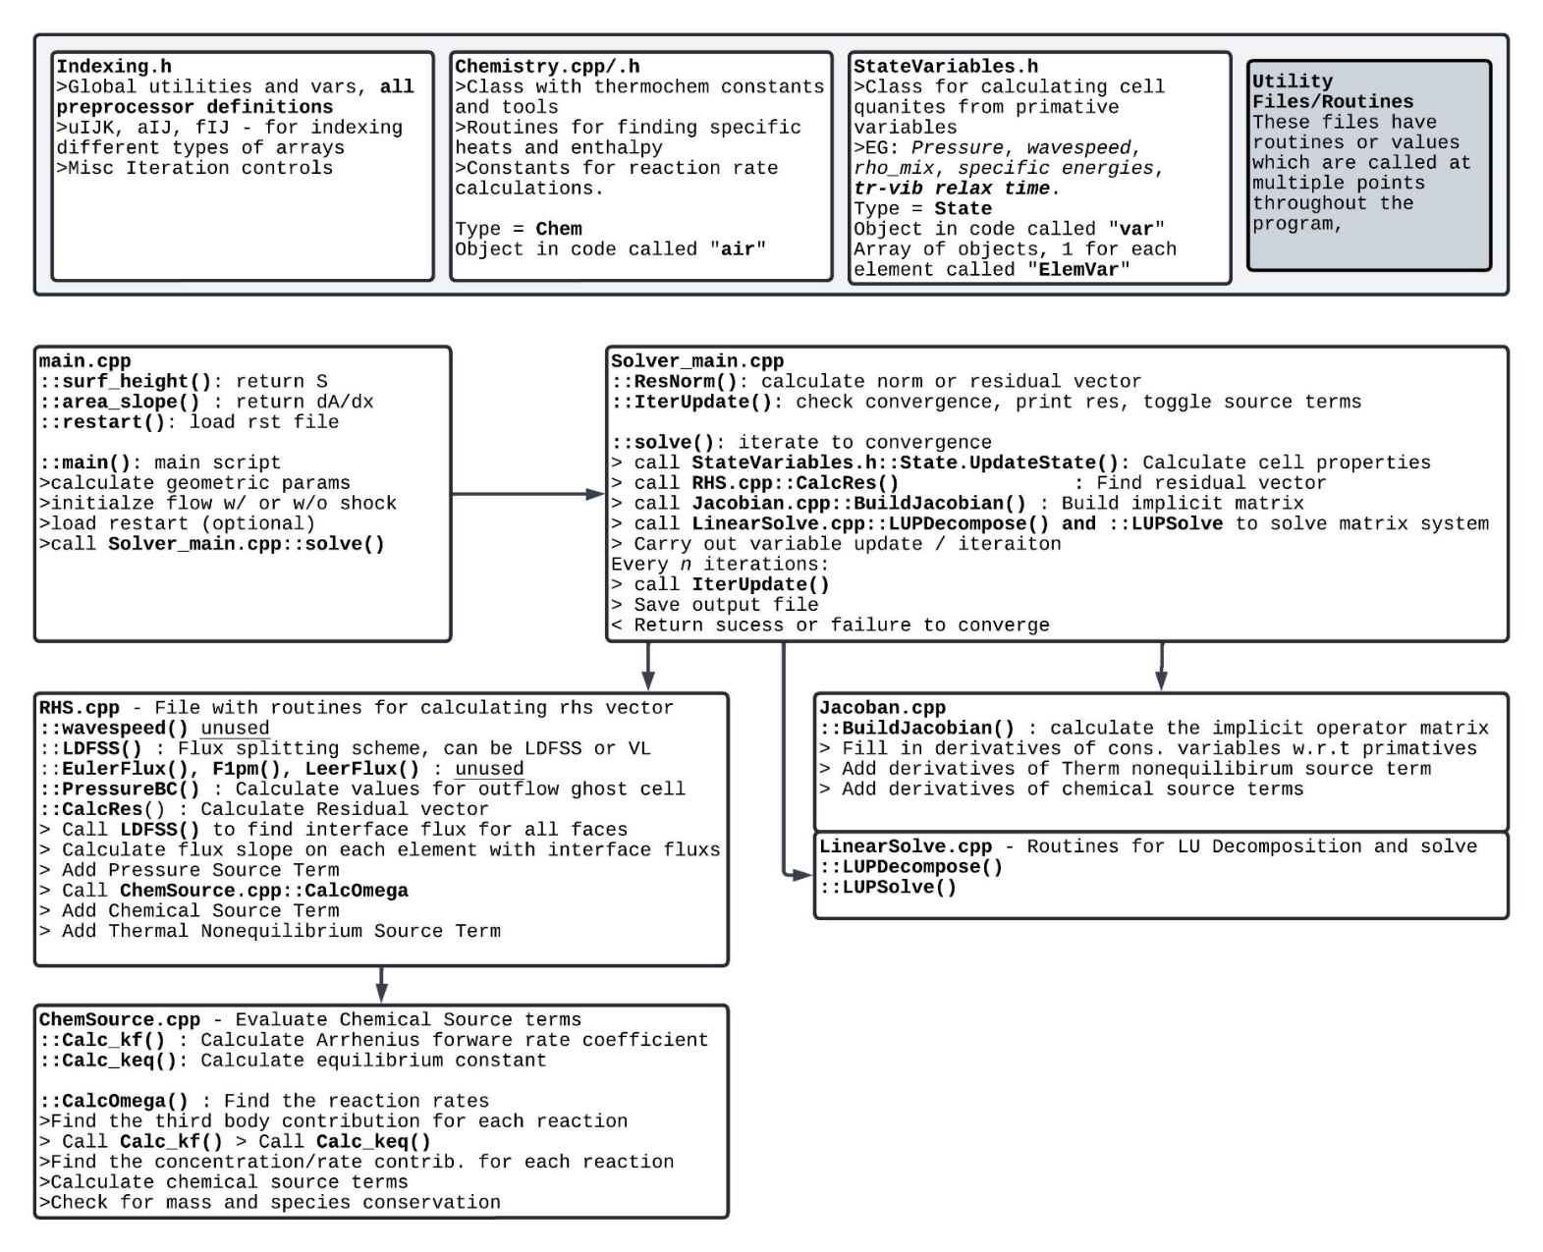**Code Map/Diagram**

Meant to be more of a map of where certain functionality is coded, rather than a complete or detailed description of the program.

1. **Baseline Solutions with Varying Degrees of Non-Equilibrium**

Solutions at the prompt’s freestream conditions and backpressure, using standard Van Leer for flux splitting and full Jacobians. Chemical source terms only active above T* > 1000K. CFL for frozen case = 0.4. CFL for non-equilibrium = 0.1. For thermal equilibrium solution, full McBride fit is used, for TNE, the Vulcan method for splitting the energies is used. Number of cells = 250.

**Velocity and Temperature**

Thermal and Chemical Equilibrium

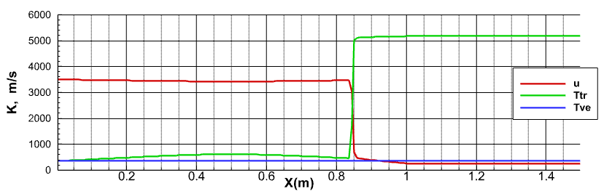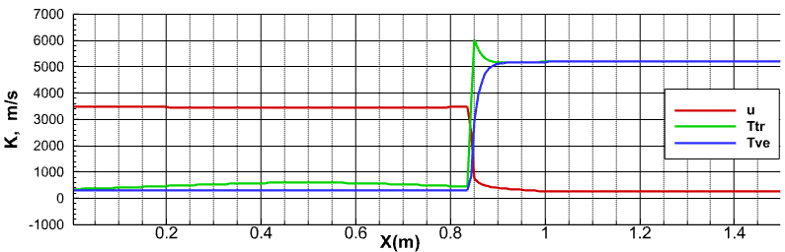

Thermal Non-Equilibrium

Chemical Equilibrium

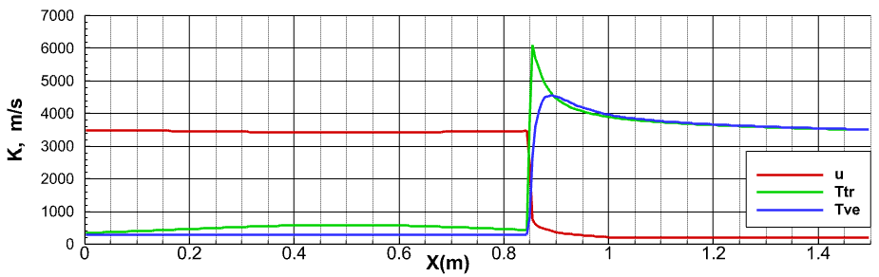

Full

Non-Equilibrium

Figure 1: Velocity and Temperature distributions for varying level of nonequilibrium flow models at the baseline conditions.

**Density, Pressure and Mach Number**

Figure 2: Comparisons of Density(left), Mach and Pressure(Right) for varying levels of non-equilibrium modeling at baseline conditions.

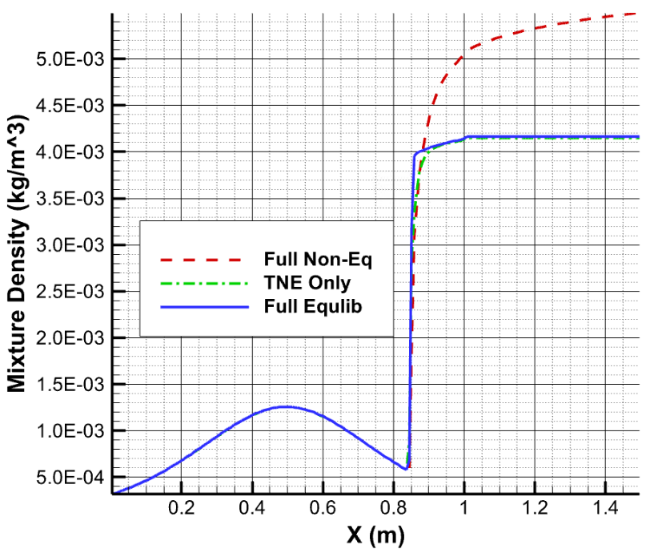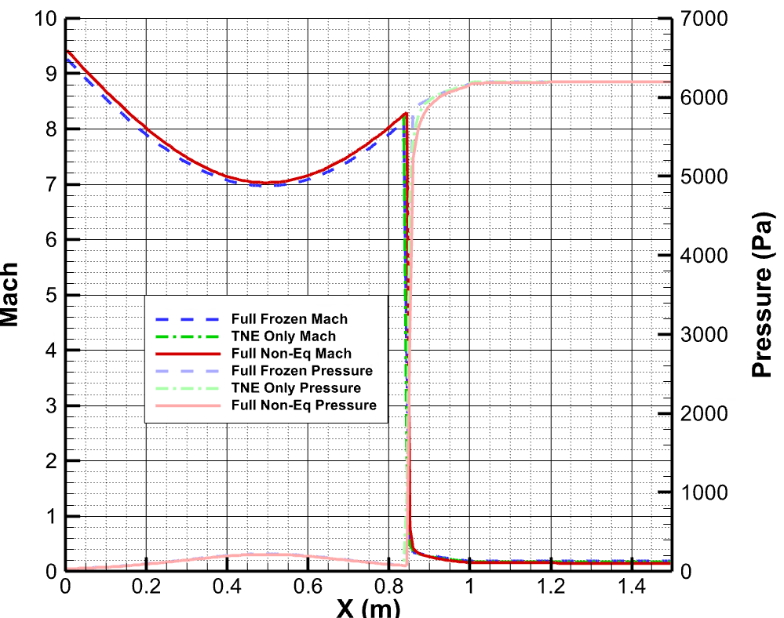

**Shock Position**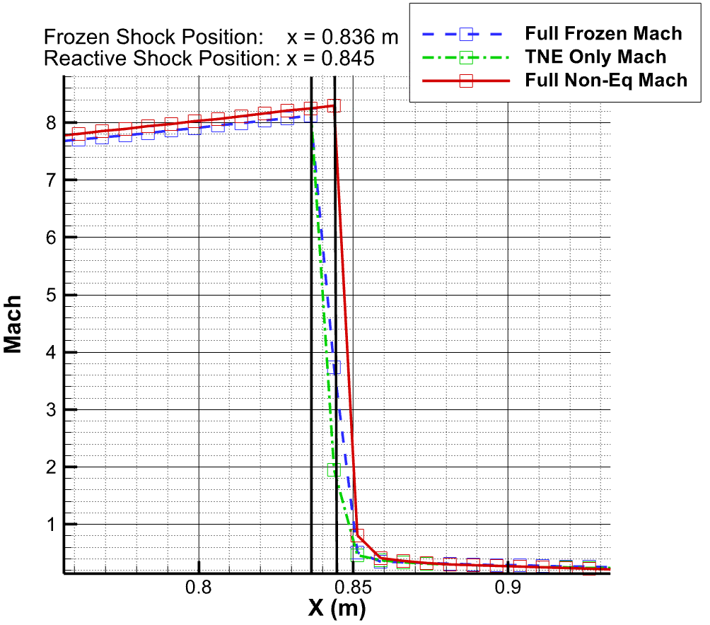

Figure 3: Shock Locations (black vertical lines) for varying levels of non-equilibrium modeling at baseline conditions.

*Shocks are tagged by their leading edge, since numerical dissipation smooths out their trailing edges

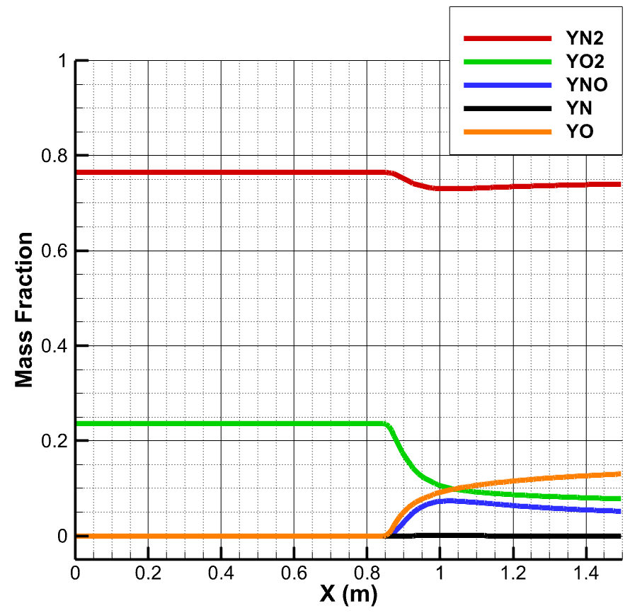

Figure 4: Mass Fraction of Baseline Full Nonequilibrium Case

For the nonreacting case, the mass fractions remain constant throughout the whole flow-field.

**Convergence History**

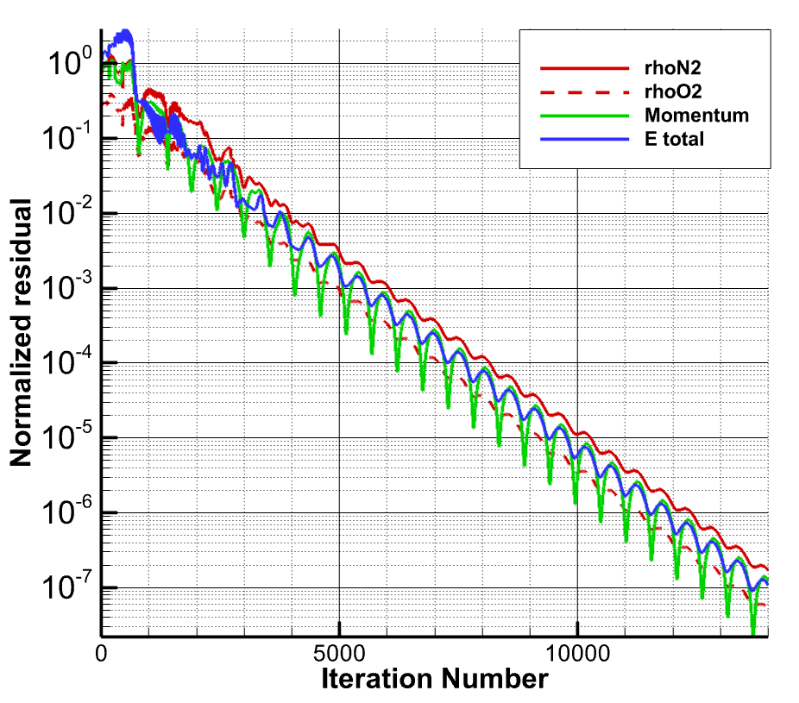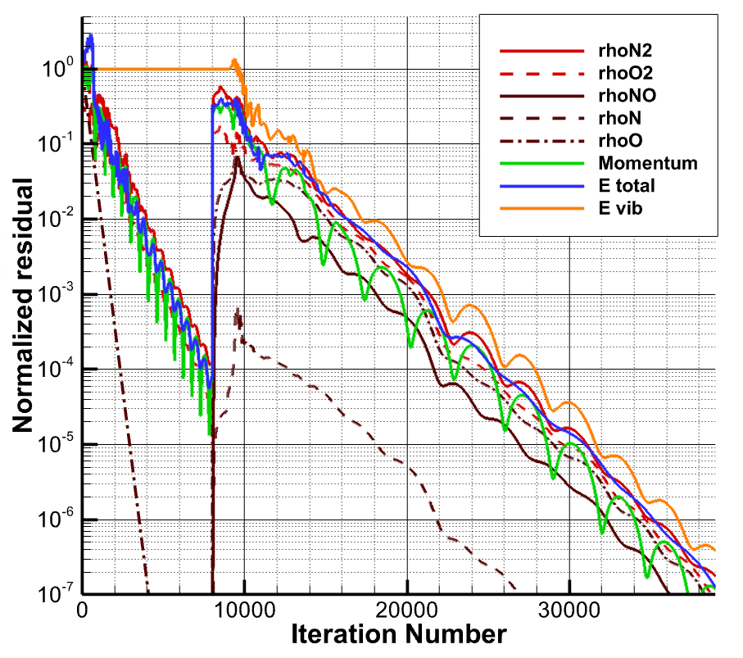

Figure 5: Convergence histories for obtaining the fully reacting (left) and fully frozen (right) solutions. The CFL number used is 0.4 for frozen iterations, and 0.1 for non-equilibrium iterations.

NOTE: The reacting solution process involves calculating the frozen solution to a loose tolerance and then activating TNE and chemical source terms.

**Analysis**

The supersonic flow through the CD nozzle behaves as we would expect from compressible flow theory. In the converging section the velocity and Mach number lowers, while the temperature, density, and pressure increase. The opposite happens for the diverging section up until the shock forms as a result of the back pressure. For the chemically frozen case, the constant area section has fairly constant flow properties. When the chemistry is introduced, the chemical reactions cause decreased temperature and thus increased density through the constant area section. This aligns with the perfect gas law (extended to mixtures) used in the program.

There is a large difference in the temperature for the 3 different level of modeling. For the thermal equilibrium case (where the vibrational temperature is just held at freestream and all sources are disabled) we see a jump in temperature to about 5000K, which remains constant in the constant-area-section. Introducing thermal non-equilibrium we see a larger jump in translational temperature, which is then brough back down by relaxation with vibrational temperature. The same final temperature is reached in the constant area section as for the thermal equilibrium case. Finally, the chemical activity increases the disparity between the translational and vibrational temperatures. The mechanism for this is by converting thermal energy into chemical energy, which causes the translational energy to fall faster from its peak before the flow has reached thermal equilibrium.

Now looking at the density, pressure, and Mach number distributions in Figure 2. We observe that there is actually very little change between the distributions of pressure and Mach for the different modeling levels. Significant things to mention are a) that the shock location is shifted backwards slightly, this is attributed to the endothermic nature of the reactions, and b), that the Mach number for the fully frozen flow is slightly different because the full McBride fits were used with the translational temperature which does not allow for the effects of vibrational temperature being effectively frozen through the isentropic compression. The density pots, on the other hand, show a large difference one the chemical reactions are enabled. Since the chemical reactions are decreasing the temperature of the system, and the pressure is remaining constant, the density must increase in accordance with the mixture of perfect gases assumption.

Figure 4 shows the mass fraction changes once the chemical source terms are enabled. The chemical timescale is both short enough to affect the thermal nonequilibrium, and also long enough to not quite reach a steady state at the end of the flow. The oxygen readily dissociates to form monoatomic oxygen and NO, whereas the nitrogen only really breaks apart to aid in the production of NO. There is only a very small amount of monoatomic oxygen remaining.

Figure 5 displays the convergence histories for the fully frozen and fully non-equilibrium solutions. Both solutions exhibit some initial transients before converging linearly on a logarithmic scale. This type of convergence is typical for explicit type methods, which aligns well with the fact that the flux is only calculated explicitly. The implicit treatment for the chemical and vibrational source terms is what allows them to add with only a small drop in the stability limit for CFL number from around 0.4 for the frozen flow to 0.1 for the nonequilibrium flow. The difference in the slope of the residuals in figure 5 demonstrates the effective reduction in convergence rate from the more restrictive CFL limit. The appears to be some type of periodic oscillation which is proportional to the CFL number. This is attributed to the rate at which information is being transported between the backpressure boundary condition and the shockwave.

**Comparing Standard Van Leer with LDFSS for Flux Splitting**

Apart from reducing the element count from 250 to 150, the same numerical setup was used to compare the solutions found using the Van Leer and LDFSS schemes for inviscid upwinding. Specifically, we are interested in the behavior of the methods around the shock.

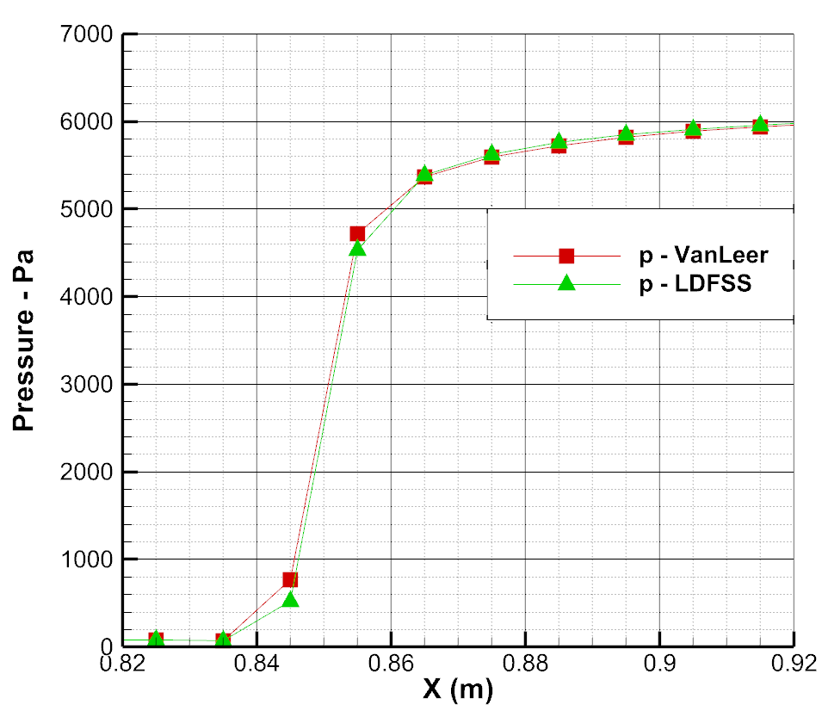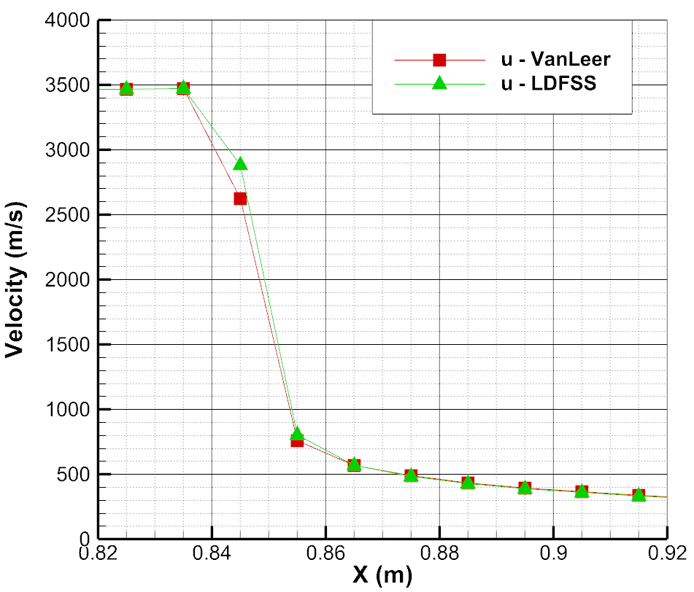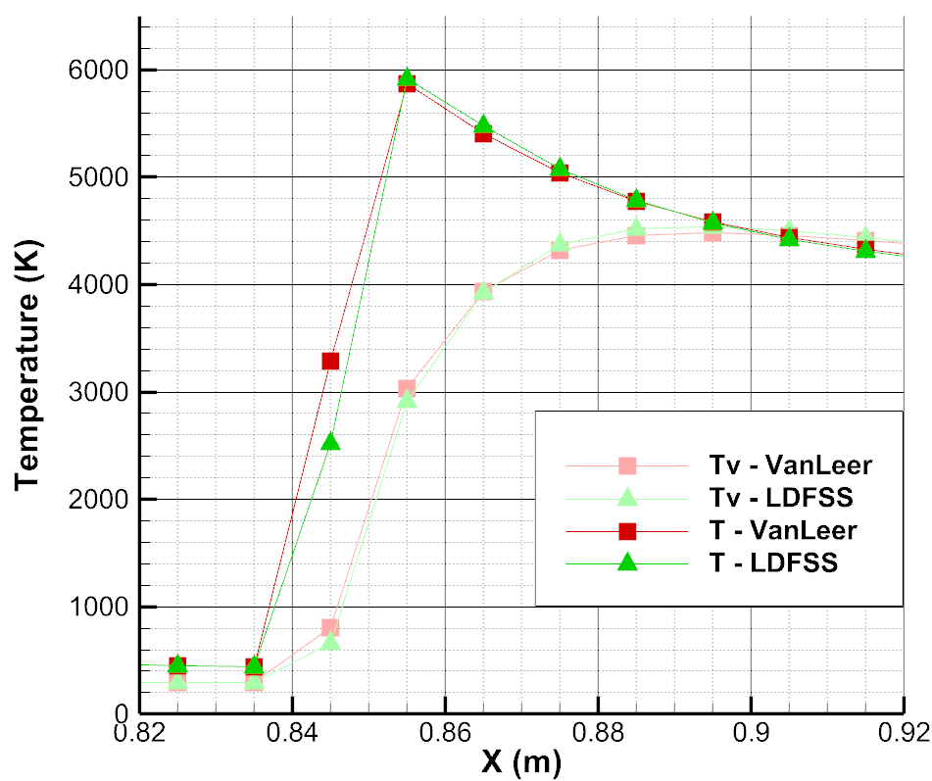

Figure 6: Coplot of flow variables around the location of the shock, comparing the solutions found using Van Leer and LDFSS for upwinding.

First looking at figure 6, there are some noticeable differences in how flow variables behave around the discontinuity between the two schemes. In all cases the LDFSS shows a slightly sharper shockwave. That is, the first cell with a change in flow property has a smaller change than the standard Van Leer scheme; then in the next cell, the LDFSS solution jumps to the same value as the VL solution. This is expected as LDFSS is a scheme made to have lover diffusivity than the standard VL scheme. Drawing attention to the coplot of temperature, the LDFSS solution has a higher peak temperature for both translational and vibrational temperatures. This is attributed to less of the ‘true’ temperature gain being lost to numerical diffusion. To substantiate this hypothesis, note compressible flow theory predicts that the post-shock temperature for a shock given those flow conditions should be around 6200 K. Chemical and Thermal nonequilibrium effects will lower that temperature as the flow continues, but immediately after the shock, we expect to see the temperature approach that theoretical number. Thus, we can say that LDFSSs capturing the flow physics better than the standard VL scheme.

Figure 7: Comparison of residual history for solutions found using LDFSS and Van Leer. For this comparison all of the separate residuals are summed together.

Now, even though the same CFL number was run for each case, there is different convergence behavior for the solutions found using the two schemes as can be seen in Figure 7. It is found that the LDFSS based method has a slightly lower convergence rate than the identical method used with VanLeer upwinding.

Figure 8: Comparison of residual history for full and simplified chemical source term jacobians. For this comparison, all of the separate residuals are summed together.

**Chemical Source Jacobian Simplifications**

Several terms in the Source term Jacobian can be neglected without significantly affecting the accuracy of the method, while decreasing the numerical cost per iteration. First, the derivatives of the reaction rates with respect to temperature were neglected. That is $\frac{∂ω_{s}}{∂T}=\frac{∂ω_{s}}{∂T_{v}}=0$. Next, the remainder of the off-diagonal derivatives of the chemical source term were neglected. That is $\frac{∂ω_{s}}{∂ρ_{k}}=0 if k≠s$. With those two simplifications made, the total runtime of the program, for initialization through frozen flow and reacting flow, was reduced from approximately **68.0** seconds to **52.5** seconds. Figure 8 shows the effect of the simplifications on the residuals over time. We can see that once the residual becomes very small, the modification to the jacobian begin to hinder the convergence rate, but it is by a negligible amount. These solutions were found using 150 cells and the LDFSS flux splitting scheme.

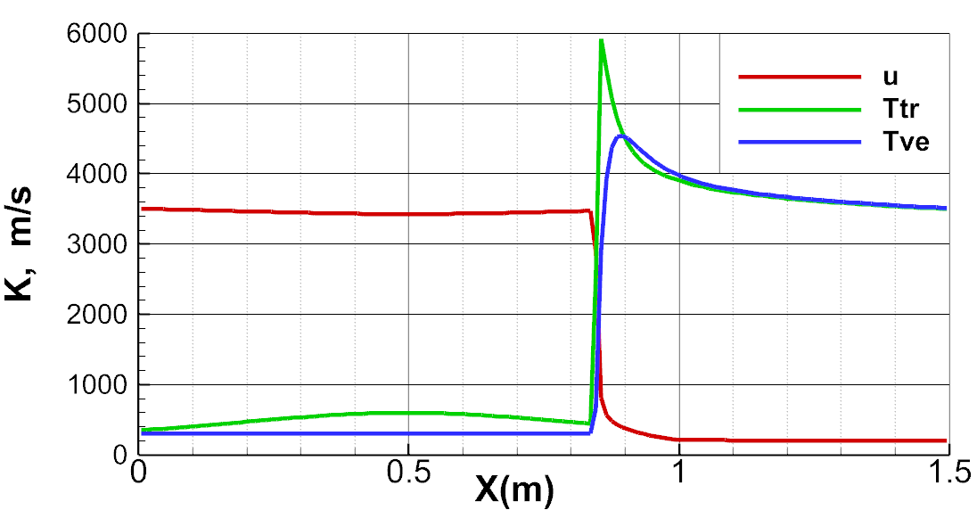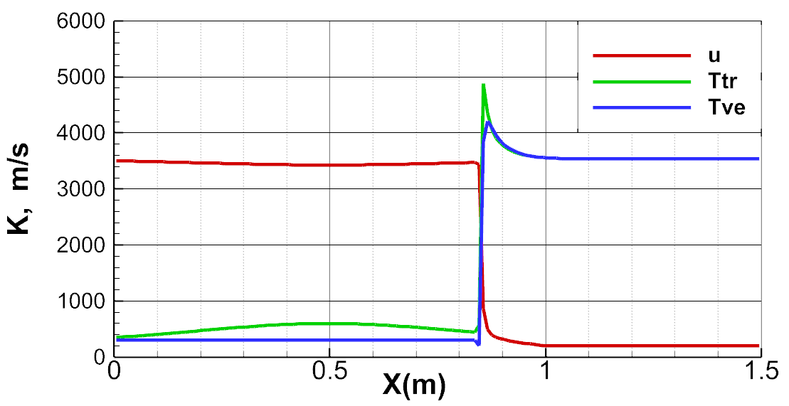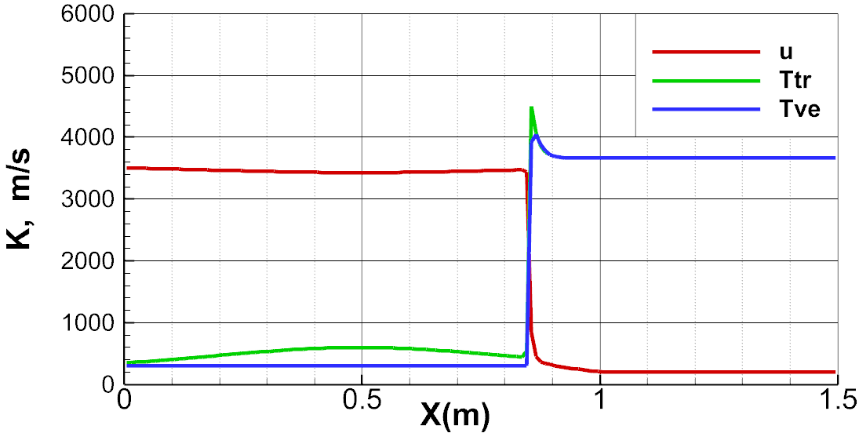

1x Density

Figure 9: Velocity and Temperature distributions for varying magnitudes of freestream mixture density.

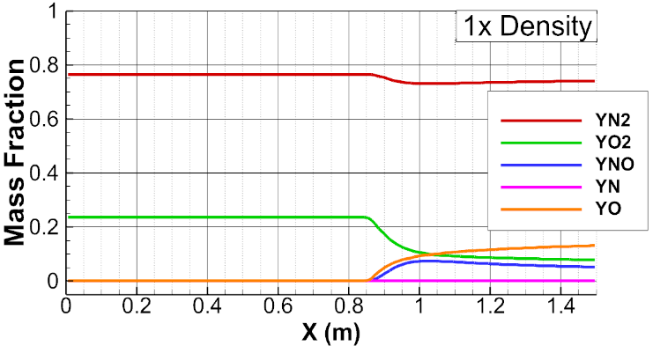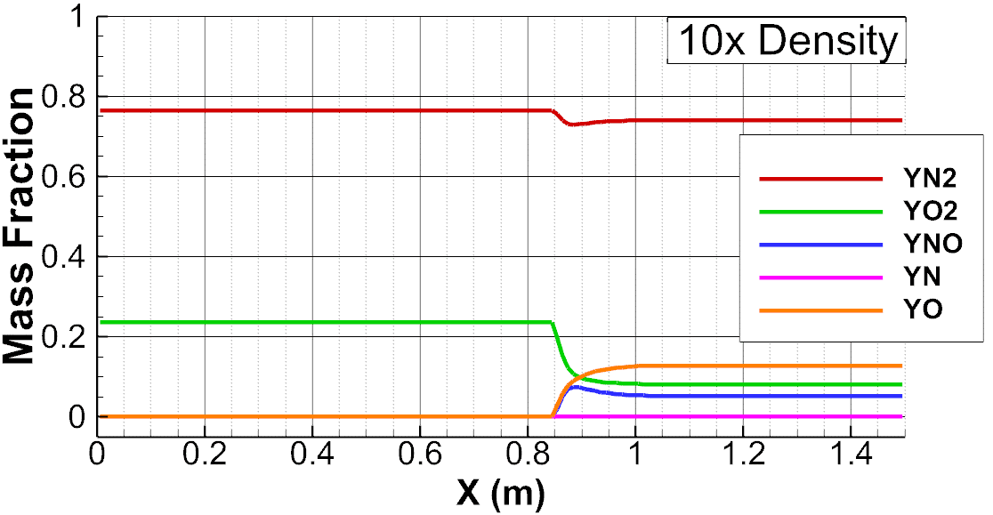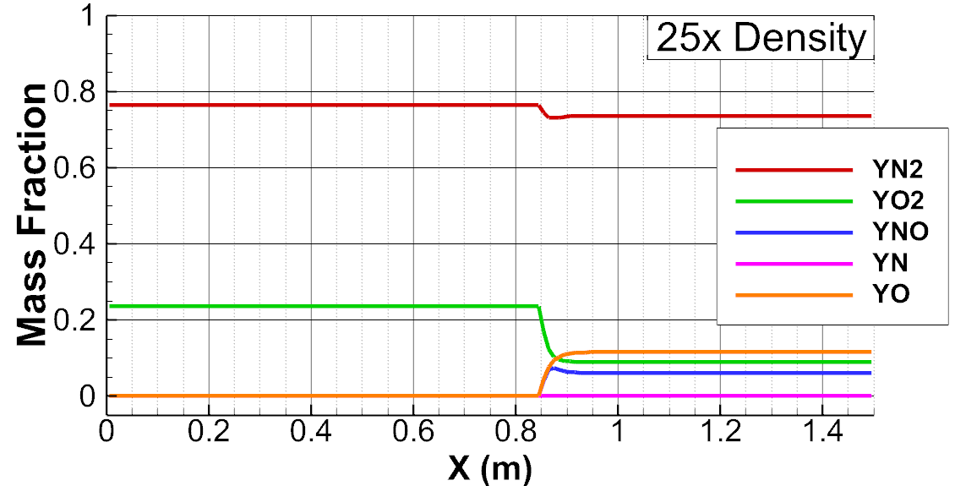

**Modifying Freestream Density**

To explore the effect of density on this problem, the freestream density was increased by factors of 10 and 25. The same initialization and solution process was then used, and the solutions are plotted below. 150 cells, LDFSS, and the simplified jacobian are used for these solutions.

25x Density

10x Density

Figures 9 and 10 show the solutions for those conditions. It is clear that increasing the density decreases the times scales(and equivalently for this problem, length scales) for both the chemical and thermal nonequilibrium. Thermal nonequilibrium is significant in the baseline solution for about 0.2 meters after the shock for the baseline solution. That length goes down to 0.05 m for the 10x density case, and 0.01 m (a single cell) for the 25x density case. For chemical nonequilibrium, the scales are larger, but show the same trend. The baseline case does not quite reach thermal equilibrium by the time the flow exits the computational domain. For the 10x density case, chemical equilibrium reaches approximately 0.18-0.2 meters after the shock; and, for the 25x density case, it shortens to 0.05 m.

Figure 10: Mass Fraction distributions for varying levels of freestream density.

**Varying Back Pressure**

The last exploration with the program was to look at the effect of changing the back pressure on the shock location, shown in Figure 11. A higher pressure case was run with a pressure ration of $p_{back}=270p_{∞}$, which pushed the shock back to x=0.75m from the original location of approx. x=0.85. A lower pressure case was also run at $p_{back}=110p_{∞}$, which puts the shock just before the end of the nozzle. If the pressure is decreased much more, the shock is blown back and out of the flow domain.

Figure 11: Velocity distributions for different pressure ratios.